Task for Bash Scripting.
Basic Shell Scripts:
- Output to screen
- Defining Tasks
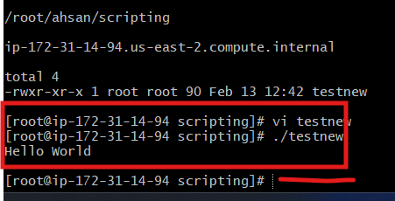
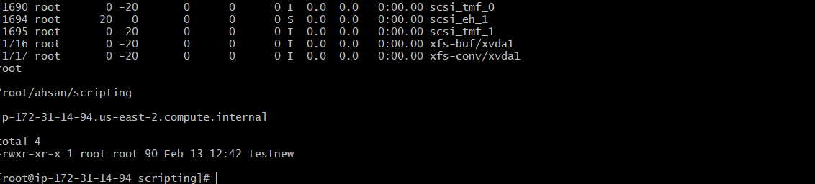
3) Defining variables
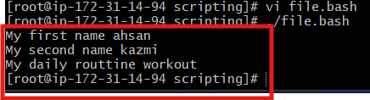
4) Read Input

